# UAT Bug 2

# Name: Mina

# Student ID: 11716113

# Assignment details: Debugging

**Version control document:** [**https://github.com/FPStruck/A4-MF/commits/main**](https://github.com/FPStruck/A4-MF/commits/main)

# A4 Bug Report

## Bug 2: Borrowing limit not enforced.

Patron can borrow more than the limit (2) and over multiple sessions.

Borrowing 3 items and reaching limit:

Borrowing another item then reaching limit:

Total item loans visible:

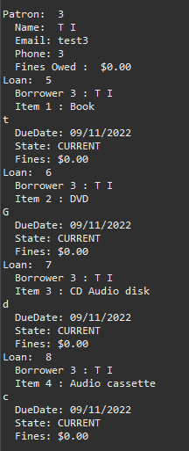

Bug 2 Solution

**Replication:** The patron has borrowed over 2 items which is the loan limit for the program. The loan limit has ben reached in one session but a separate session allows the patron to borrow more items

# Scenario 1: Patron borrows more items in two separate sessions

## Scenario Description

* This scenario is made to test if the borrowing of items is limited by the program. If the patron attempts to borrow more, the program should not allow them.
* The test is used to determine which part of the program is faulty and needs adjustment in order to function as intended
* This scenario is based on a patron’s need to borrow multiple items over two sessions.

## Version Control

|  |  |  |  |
| --- | --- | --- | --- |
| Version # | Date | Author | Description |
| 0.1 | 18/10/2022 | Mina Farag | Initial Draft |
| 1.0 | 18/10/2022 | Mina Farag | Initial Version |

## Test Scripts

The following scripts will cover this scenario:

* 1.1 Loan issue case
* 1.2 Item issue case

## Use Case

* The use case covered by this scenario will be the issuing of loans and items.

## Test Components/Requirements

This test scenario covers the following high-level test requirements (see scripts below for specific requirements covered by each test script):

* Patron
* Loan
* Item

## User Groups

* Actor/Patron

## Script 1: Overdue Loan Case

### Script Description

* Loan limit has been reached yet the patron is able to borrow more

### Testing Requirements

This test script covers the following specific testing requirements:

* A member cannot borrow when they have reached the loan limit.
* A member must not be able to borrow more items over separate sessions if they have reached the limit

### Setup

* Member has an account in the system
* Items must be input into the system
* The member must be able to borrow

### Teardown

* Attempt to fix issue of incorrect loan issue to patron who reached loan limit

### Script Steps

| **Step #** | **Test Action** | **Expected Results** | **Pass/ Fail** |
| --- | --- | --- | --- |
| 1 | Patron attempts to borrow two items in one session | Items should be applied | Pass |
| 2 | Patron attempts to borrow a third item in the same session | Loan limit must be reached and item not applied | Fail |
| 3 | In a separate session, the patron attempts to borrow more items | Because the patron’s loan limit has been reached, an error should be returned and an item cannot be borrowed | Fail |
| 4 |  |  |  |
| 5 |  |  |  |
| 6 |  |  |  |
| 7 |  |  |  |
| 8 |  |  |  |
| 9 |  |  |  |

### Test Data

|  |  |
| --- | --- |
| Step | Data |
| 1 | Member Id: 4 |
| 2 | Item Id: 1, 2, 3, 4, 5 |
| 3 | Loan Id: 1 |

### Test Execution

|  |  |  |  |  |
| --- | --- | --- | --- | --- |
| Date/Time | Tester | Test ID | Test Phase | Status |
| 7/11/2022 | YH | 1 | Step 1 | Passed |
| 7/11/2022 | YH | 1 | Step 2 | Fail |
| 7/11/2022 | YH | 1 | Step 3 | Fail |

Step 1 Result: Pass

**Screen shot displays patron having two items borrowed in the same session**

Step 2 Result: Fail

More than 3 items have been applied to the loan before the loan limit error is shown.

Step 3 Result: Fail

Screenshot displays patron having a 4th item being borrowed in a separate loan

Version control:

**Commit of UATB2 doc to Version Control Repo**

**Simplification**

**H0: From my understanding of the problem. My guess is that the loan limit and the amount of loans for a single user have been acknowledged by the program and but a limit has not been enforced.**

**T0: I will be applying multiple loans to a single user and investigate if the program has acknowledge that the user has more than the accepted amount of loans**

**R0: Below is the test I have conducted on the library.getLoanLimit() and library.getNumberOfLoansRemainingForPatron()**

**(Screenshots)**

**Testing library.getLoanLimit() and library.getNumberOfLoansRemainingForPatron() methods (Expected that the program will display a loan limit of 2 but the remaining loans will be -3 because the patron has a total of 5 loans) PASS**

**Testing library.getLoanLimit() and patron.getNumberOfLoans() methods (Expected that the program will display a loan limit of 2 and patron number of loans will be 5) PASS**

**Version control:**

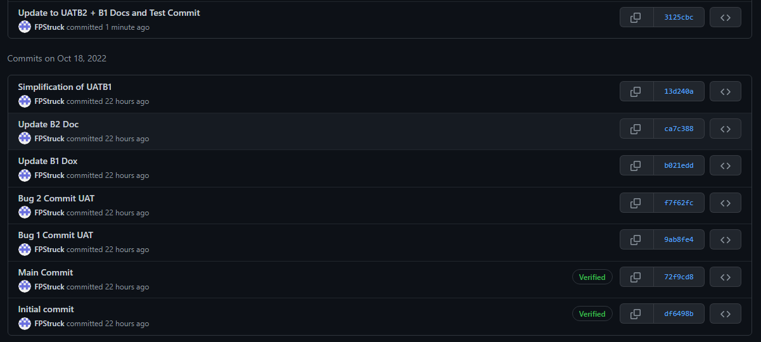

**Commit of UATB2 doc to Version Control Repo**

**Tracing**

**The test conducted below is to make sure that the problem occurs before any changes are made to the code**

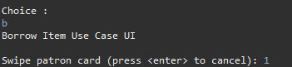

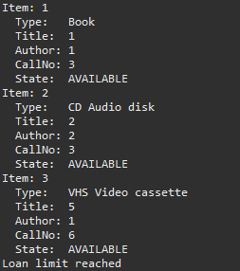

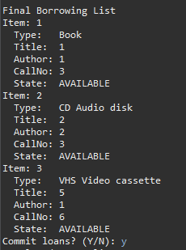

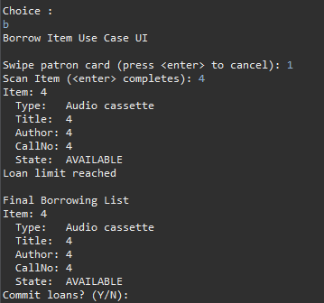

**H0: The problem in my opinion occurs from a method that is made to enforce the loan limit but it does not have the correct implementation to do so. I suspect that the bug is located or caused by the library.java file or the BorrowItemControl.java file which implements the borrowing of items.**

**T0: Tests have been conducted in the debug log. The origin of the bug has been identified in the variable BorrowItemControl.java file. Below is the variable that caused the bug.**

**R0:**

**Before origin is identified:**

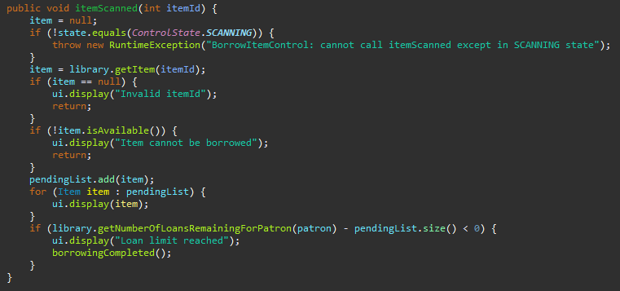

Sane Variables

**Result output of borrowing more than two items (in more than one session):**

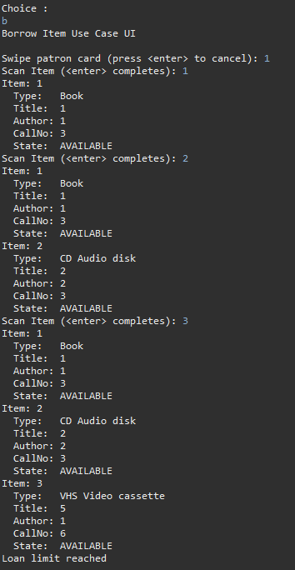

**After origin is identified:**

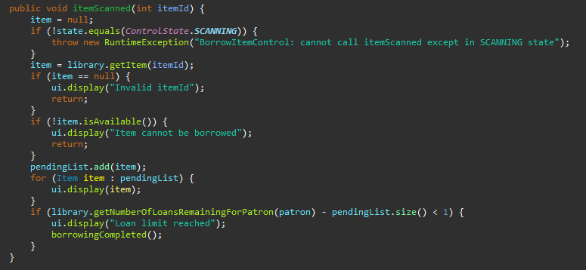

Infected code

**Result output of borrowing more than two items (in more than one session):**

**Version control:**

**Resolution**

**H0: After using the tracing method to determine the location of the infected code. The code modifications have been applied and a JUNIT test will be done to make sure that no more than two loans are allowed to be held by a single patron.**

**T0: This test will be a repeat of the first JUNIT test to determine whether the code error has been resolved or not.**

**The test conducted determines if the patron is capable of having more than two loans (the result should be false)**

**Furthermore, the number of loans remaining for the patron should equal 0:**

**Because loans can be forcibly applied to the patron, the patron can still obtain more than two loans in JUNIT:**

**R0: The bug has been successfully resolved**

**Correct code:**

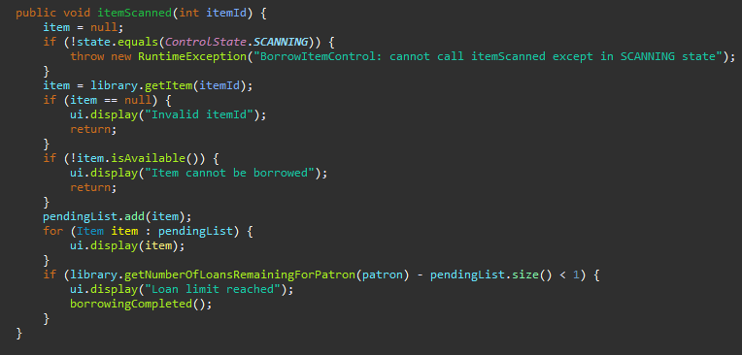

**Test screenshot:**

**Version control:**

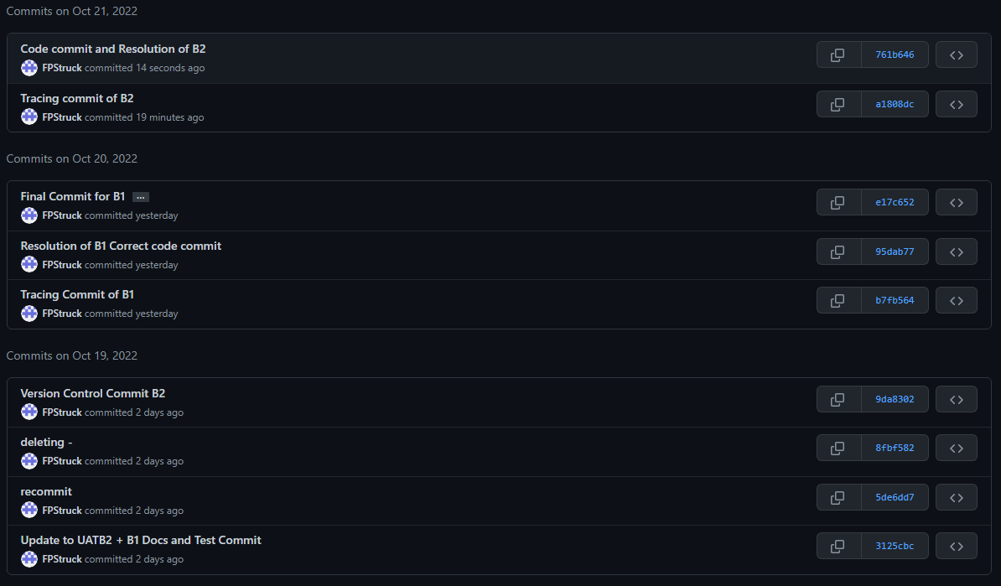

**User test case**

# Scenario 1: Patron attempts to borrow more items in two separate sessions

## Scenario Description

* This scenario is made to test if the borrowing of items is limited by the program. If the patron attempts to borrow more, the program should not allow them.
* The test is used to determine which part of the program is faulty and needs adjustment in order to function as intended
* This scenario is based on a patron’s need to borrow multiple items over two sessions.

## Version Control

|  |  |  |  |
| --- | --- | --- | --- |
| Version # | Date | Author | Description |
| 0.1 | 21/10/2022 | Mina Farag | Initial Draft |
| 1.0 | 21/10/2022 | Mina Farag | Initial Version |

## Test Scripts

The following scripts will cover this scenario:

* 1.1 Loan issue case
* 1.2 Item issue case

## Use Case

* The use case covered by this scenario will be the issuing of loans and items.

## Test Components/Requirements

This test scenario covers the following high-level test requirements (see scripts below for specific requirements covered by each test script):

* Patron
* Loan
* Item

## User Groups

* Actor/Patron

## Script 1: Overdue Loan Case

### Script Description

* Testing that the loan limit has been reached and if the patron is able to borrow more

### Testing Requirements

This test script covers the following specific testing requirements:

* A member cannot borrow when they have reached the loan limit.
* A member must not be able to borrow more items over separate sessions if they have reached the limit

### Setup

* Member has an account in the system
* Items must be input into the system
* The member must be able to borrow

### Teardown

* If error occurs. Attempt to fix. Otherwise, test was successful.

### Script Steps

| **Step #** | **Test Action** | **Expected Results** | **Pass/ Fail** |
| --- | --- | --- | --- |
| 1 | Patron attempts to borrow two items in one session | Items should be applied and loan limit must be reached and displayed | Pass |
| 2 | Patron attempts to borrow a third item in a separate session | Loan limit must be reached and item not applied | Pass |
| 3 | In a separate session, the patron attempts to borrow more items | Because the patron’s loan limit has been reached, an error should be returned and an item cannot be borrowed | Pass |
| 4 |  |  |  |
| 5 |  |  |  |
| 6 |  |  |  |
| 7 |  |  |  |
| 8 |  |  |  |
| 9 |  |  |  |

### Test Data

|  |  |
| --- | --- |
| Step | Data |
| 1 | Member Id: 1 |
| 2 | Item Id: 1, 2, 3 |
| 3 | Loan Id: 1, 2 |

### Test Execution

|  |  |  |  |  |
| --- | --- | --- | --- | --- |
| Date/Time | Tester | Test ID | Test Phase | Status |
| 24/10/2022 | JJ | 1 | Step 1 | Passed |
| 24/10/2022 | JJ | 1 | Step 2 | Passed |
| 24/10/2022 | JJ | 1 | Step 3 | Passed |

**Screenshots of scenario:**

**Attempting to start a second session:**

**Attempting to start a third session:**

